**Software Requirements Specification**

**for**

ComfortRead

**Version 1.0 approved**

**Prepared by <authors>**

**<organization>**

**<date created>**

**Table of Contents**

**Table of Contents ii**

**Revision History ii**

**1. Introduction 1**

1.1 Purpose 1

1.2 Document Conventions 1

1.3 Intended Audience and Reading Suggestions 1

1.4 Product Scope 1

1.5 References 1

**2. Overall Description 2**

2.1 Product Perspective 2

2.2 Product Functions 2

2.3 User Classes and Characteristics 2

2.4 Operating Environment 2

2.5 Design and Implementation Constraints 2

2.6 User Documentation 2

2.7 Assumptions and Dependencies 3

**3. External Interface Requirements 3**

3.1 User Interfaces 3

3.2 Hardware Interfaces 3

3.3 Software Interfaces 3

3.4 Communications Interfaces 3

**4. System Features 4**

4.1 System Feature 1 4

4.2 System Feature 2 (and so on) 4

**5. Other Nonfunctional Requirements 4**

5.1 Performance Requirements 4

5.2 Safety Requirements 5

5.3 Security Requirements 5

5.4 Software Quality Attributes 5

5.5 Business Rules 5

**6. Other Requirements 5**

**Appendix A: Glossary 5**

**Appendix B: Analysis Models 5**

**Appendix C: To Be Determined List 6**

**Revision History**

| **Name** | **Date** | **Reason For Changes** | **Version** |
| --- | --- | --- | --- |
| Ben Yandell | 10/19/2024 | Adding positive language to requirement NF-REC 5.1 |  |
| Ben Yandell | 11/10/2024 | Updated 1.1, 1.2, 1.3, 1.4, 1.5, 2.1, 2.2, 2.4 | 1.02 |

# **Introduction**

## **Purpose**

ComfortRead is an accessible digital reading application designed to improve reading comfort and engagement for a variety of users, but primarily aiding those with neurodivergent disorders such as ADHD and Dyslexia. The primary objective of ComfortRead is to offer customizable text reformatting tools, which allows users to choose the way they want to read through options such as bionic reading, adjustable formatting, and enabling darkmode. This document outlines the software requirements necessary to develop ComfortRead, a platform for personalized reading.

## **Document Conventions**

This document was created based on the IEEE template detailing System Requirements Specifications Documents.

| **Convention** | **Description** |
| --- | --- |
| Firebase | Backend Service |

## **Intended Audience and Reading Suggestions**

The document is made for developers, project managers, users, testers, marketing officials, and document writers. The remaining SRS contains the product scope, product descriptions, external interface requirements, system features, non-functional requirements, and other requirements.

## **Product Scope**

ComforRead is a reading assistance and accessibility focused application that enhances readability and engagement for a variety of readers by offering customizable text options. The primary purpose is to provide a better reading experience through a multitude of features such as bionic reading, text customization, and darkmode. These features aim to make reading more comfortable and accessible, especially for those who experience neurodivergent disorders and prefer a tailored reading experience. The development of ComfortRead aligns with more broader goals of promoting accessibility and inclusivity. By focusing on usability and personalization, ComfortRead seeks to create a platform that enhances focus, retention, and satisfaction in the digital reading realm.

## **References**

ComfortRead Github Link: [*https://github.com/COS420-Fall24/TeamC*](https://github.com/COS420-Fall24/TeamC)

# **Overall Description**

## **Product Perspective**

ComfortRead is a new digital reading application that is not intended to replace any existing product. It has been designed from the ground up to address specific needs of users seeking a personalized and improved reading experience. ComfortRead is a standalone platform being created using open-source code.

## **Product Functions**

Account Login:

1. Input Username: Allows user to input their username to access account.
2. Input Password: Allows user to input their password to access account.

Text Reformatting:

1. Change Font Size: Allows user to change Font Size.
2. Change Color: Allows User to change Font Color

Background:

1. Darkmode: Allows user to enable Darkmode.

## **User Classes and Characteristics**

*<Identify the various user classes that you anticipate will use this product. User classes may be differentiated based on frequency of use, subset of product functions used, technical expertise, security or privilege levels, educational level, or experience. Describe the pertinent characteristics of each user class. Certain requirements may pertain only to certain user classes. Distinguish the most important user classes for this product from those who are less important to satisfy.>*

## **Operating Environment**

ComfortRead will operate in a variety of environments to ensure broad accessibility across different platforms and devices.

**Hardware:** Compatible with desktop and mobile devices to include, PCs, laptops, tablets, and smartphones.

**Operating System:**

**Other Components:**

## **Design and Implementation Constraints**

*<Describe any items or issues that will limit the options available to the developers. These might include: corporate or regulatory policies; hardware limitations (timing requirements, memory requirements); interfaces to other applications; specific technologies, tools, and databases to be used; parallel operations; language requirements; communications protocols; security considerations; design conventions or programming standards (for example, if the customer’s organization will be responsible for maintaining the delivered software).>*

## **User Documentation**

*<List the user documentation components (such as user manuals, on-line help, and tutorials) that will be delivered along with the software. Identify any known user documentation delivery formats or standards.>*

## **Assumptions and Dependencies**

*<List any assumed factors (as opposed to known facts) that could affect the requirements stated in the SRS. These could include third-party or commercial components that you plan to use, issues around the development or operating environment, or constraints. The project could be affected if these assumptions are incorrect, are not shared, or change. Also identify any dependencies the project has on external factors, such as software components that you intend to reuse from another project, unless they are already documented elsewhere (for example, in the vision and scope document or the project plan).>*

# **External Interface Requirements**

## **User Interfaces**

[*https://miro.com/welcomeonboard/QUF0d0RoWml4a2tWc2RDcXhtaEJIc002QjNxdWFBdnVZUU5VQWkzNWRsSWpqVWprUm5vRFB1YVh3cmtZN3VXVXwzNDU4NzY0NjAwNTYzNTk4MDI1fDI=?share_link_id=686049626358*](https://miro.com/welcomeonboard/QUF0d0RoWml4a2tWc2RDcXhtaEJIc002QjNxdWFBdnVZUU5VQWkzNWRsSWpqVWprUm5vRFB1YVh3cmtZN3VXVXwzNDU4NzY0NjAwNTYzNTk4MDI1fDI=?share_link_id=686049626358)

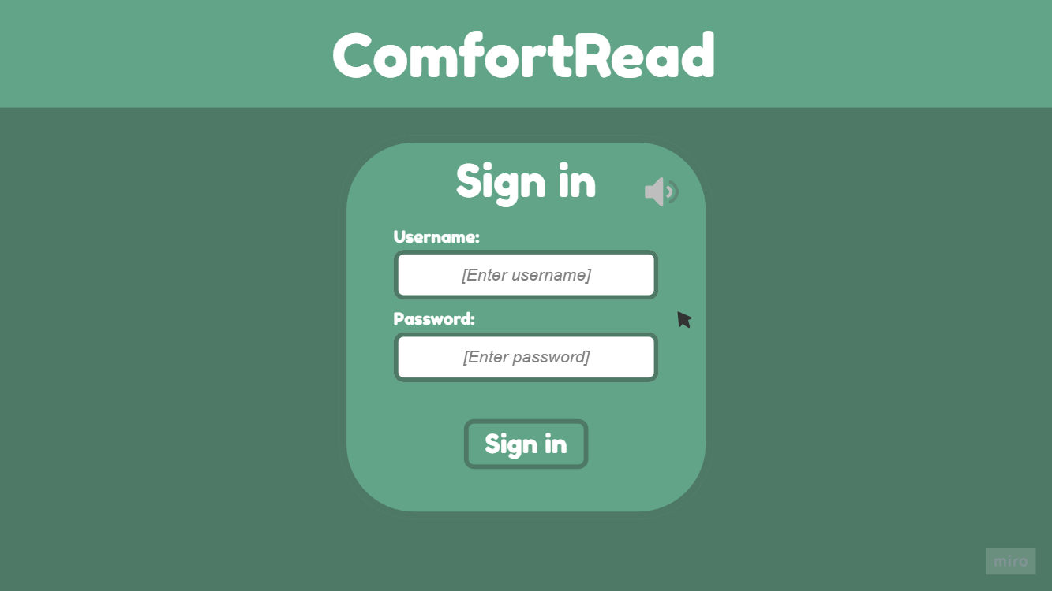

*Sign in page*

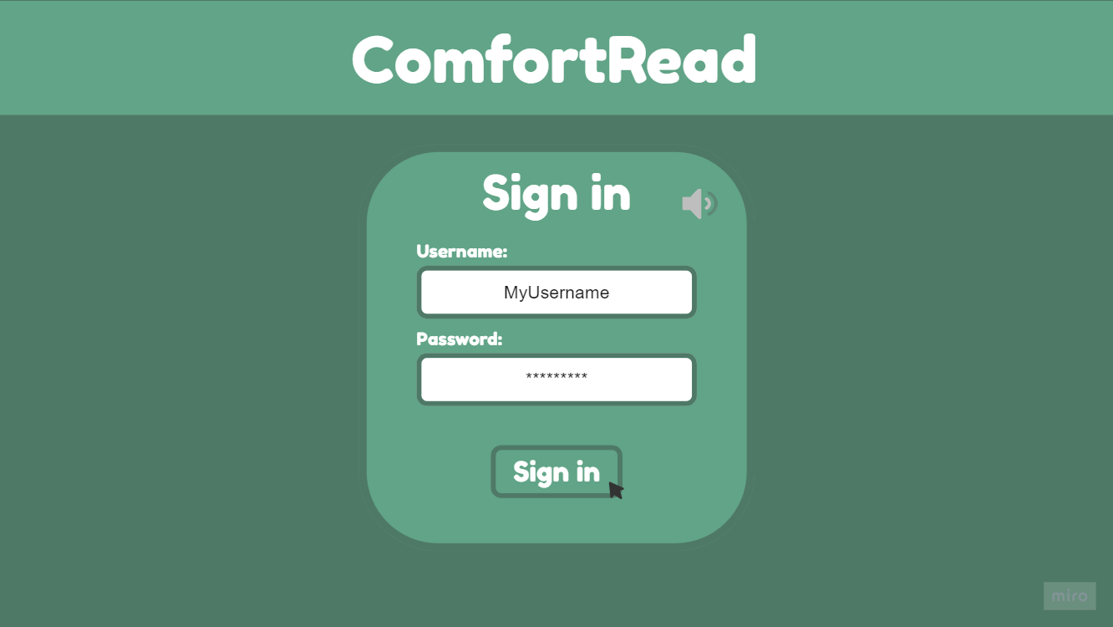

*Sign in page with info typed out*

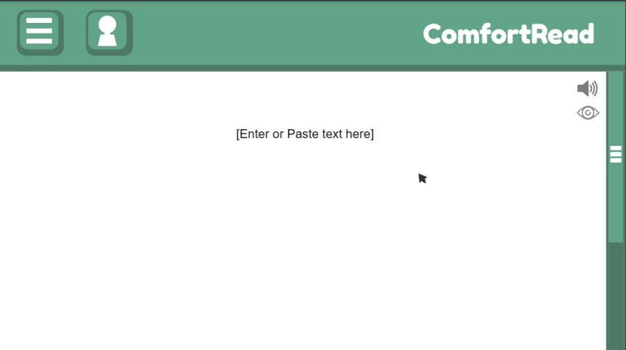

**The ComfortRead main screen on site loaded, user can paste in text, open the options menu, or open account menu**

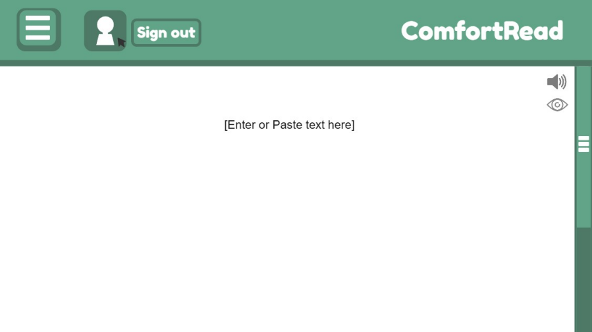

**User clicks account box while signed in**

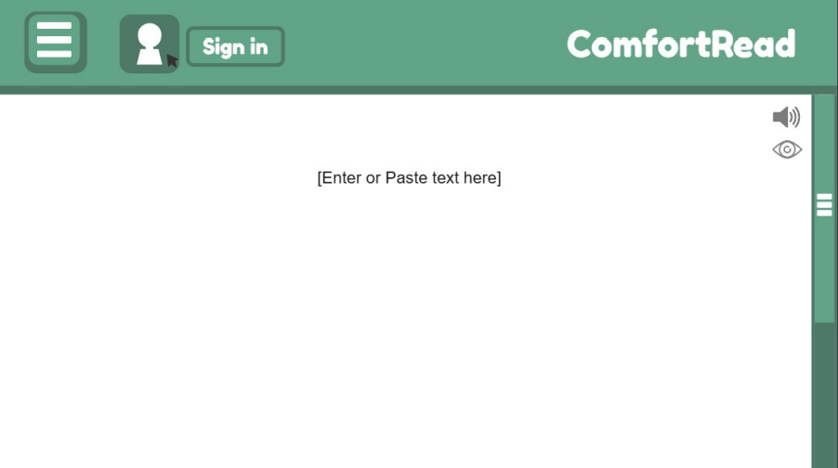

**User clicks account box while signed out**

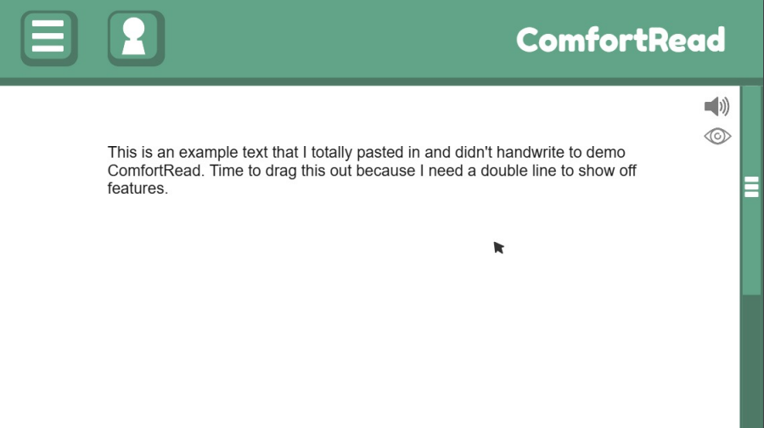**User pastes in text into text space**

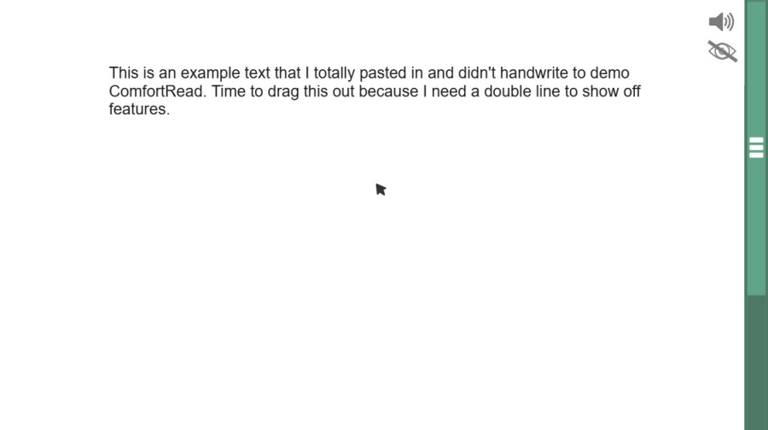

**User enables Focus mode (eye icon)**

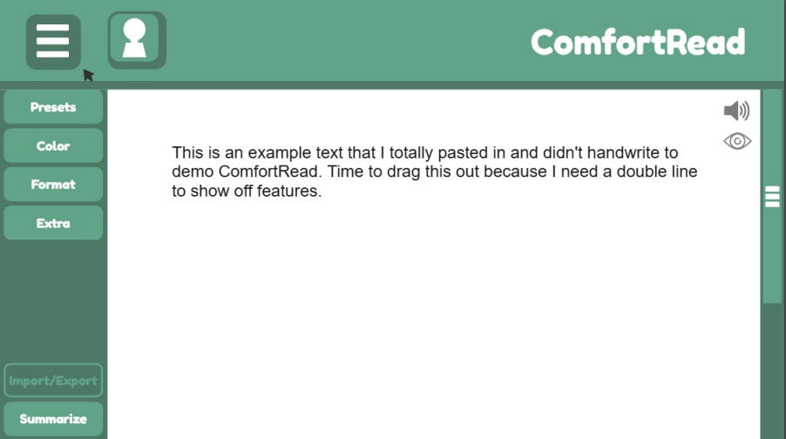

**User drops down options menu while signed out (Can no longer import/export)**

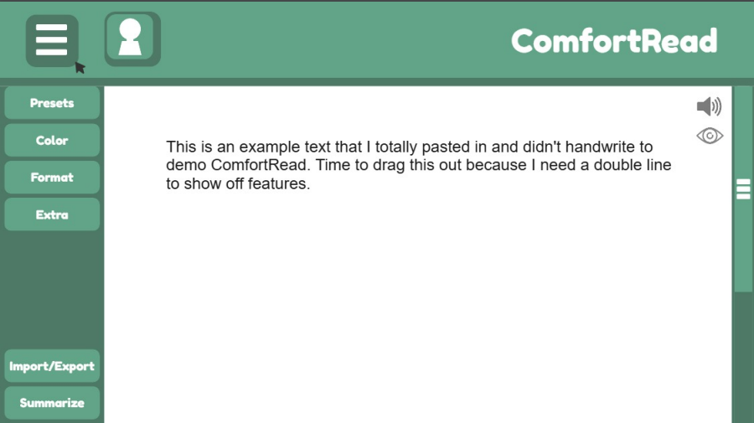

**User drops down options menu while signed in (Can import/export)**

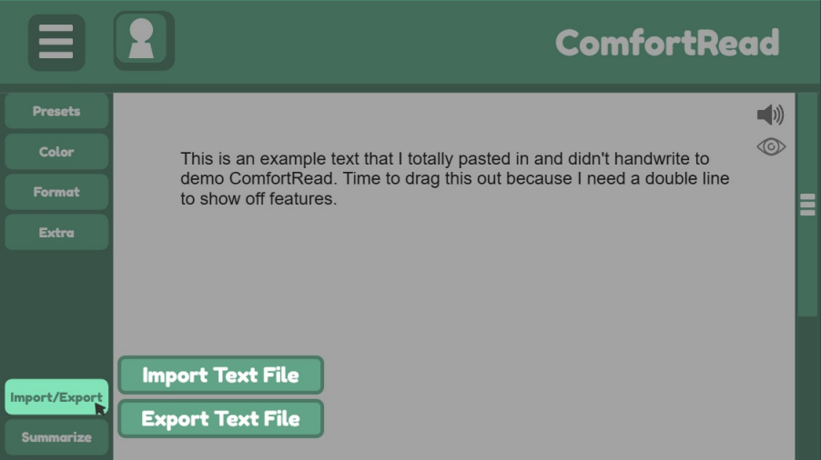

**User clicks import/export**

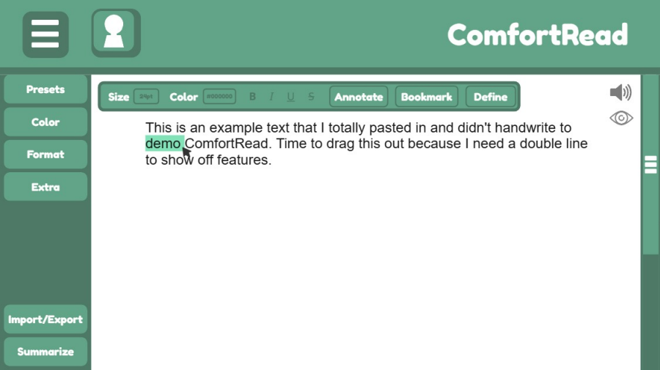

**User highlights text (Opens a new options menu)**

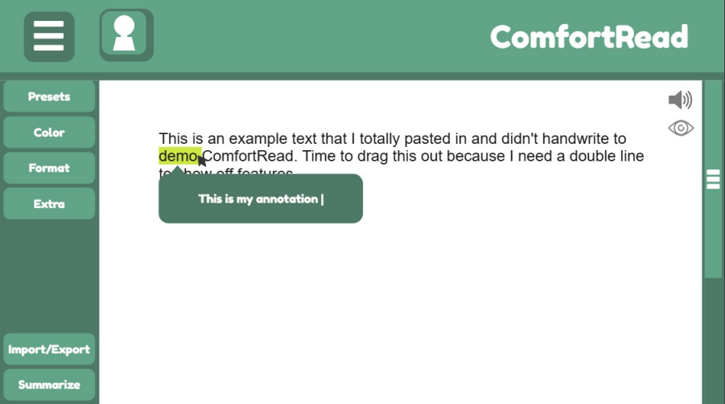

**User clicks “Annotate” in the highlight menu**

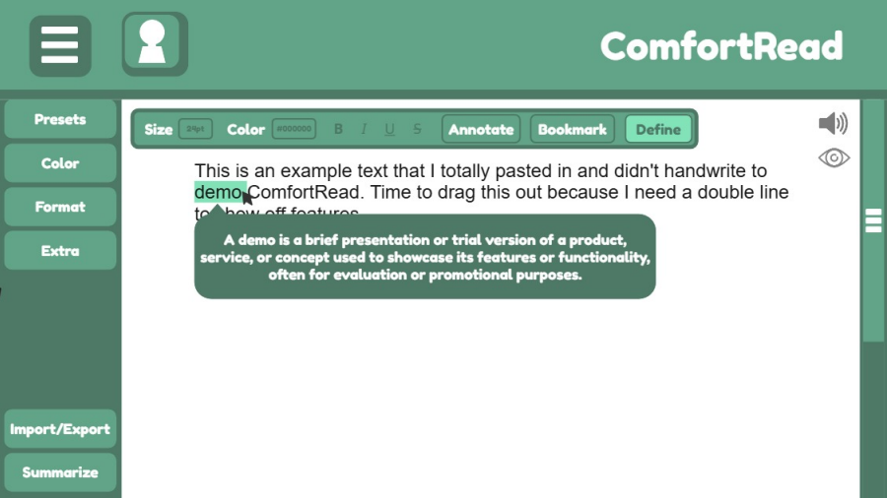

**User clicks “Define” in the highlight menu**

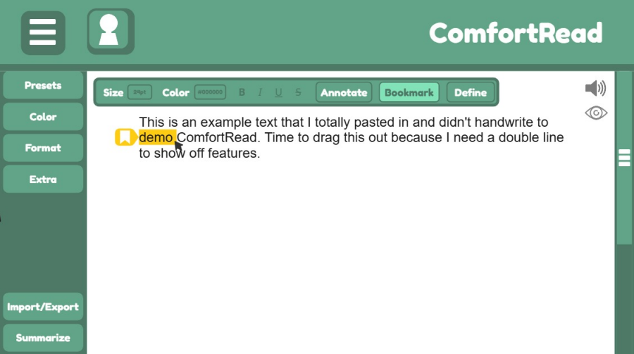

**User clicks “Bookmark in highlight menu”**

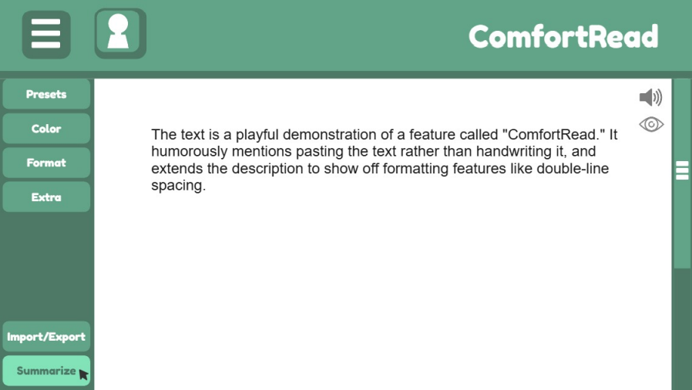

**User clicks summarize (OpenAI summarizes the page)**

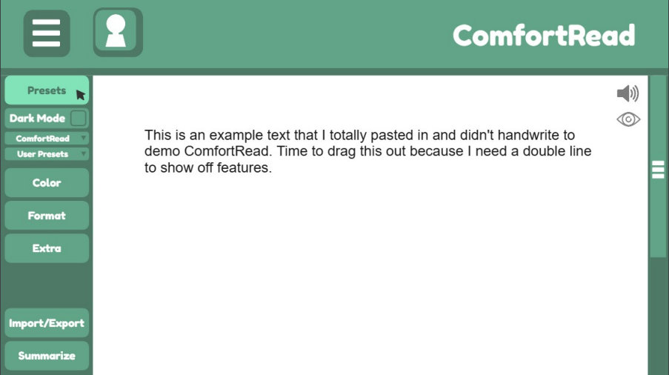

**Example of user opening one of the options under the options dropdown menu (Presets)**

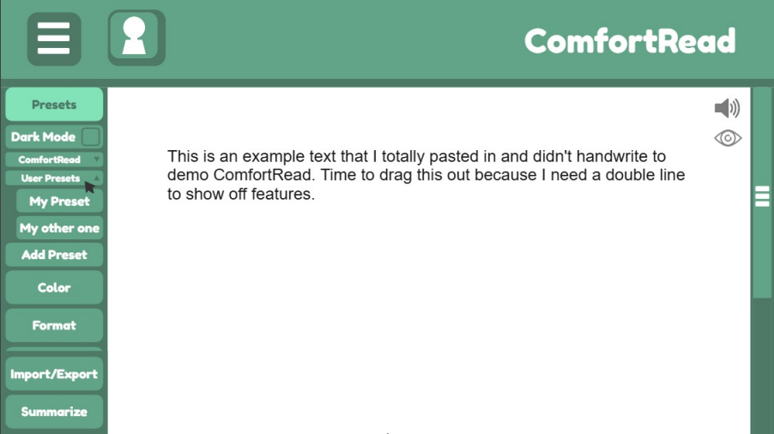

**User expands “User Presets” option within Presets menu**

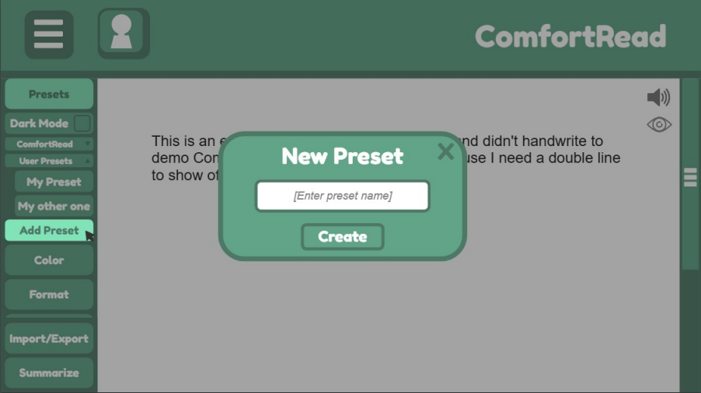

**Click “Add Preset”**

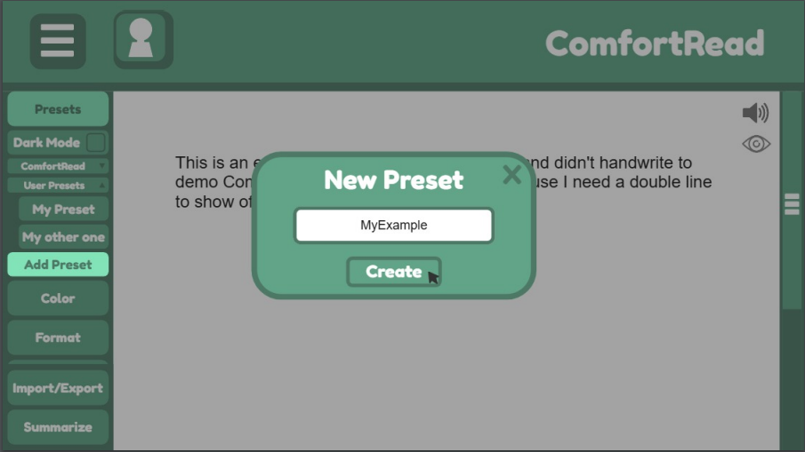

**Enter new preset name**

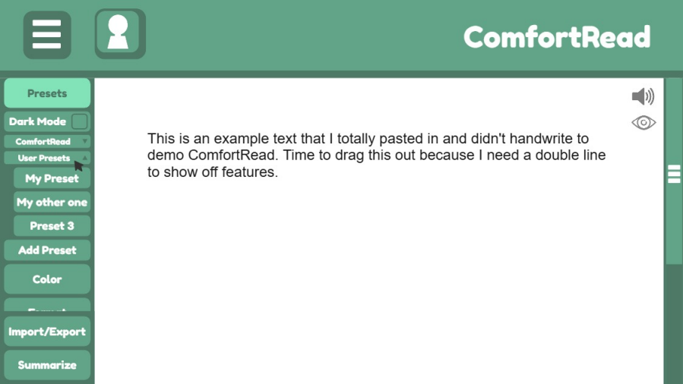

**Create new preset without name**

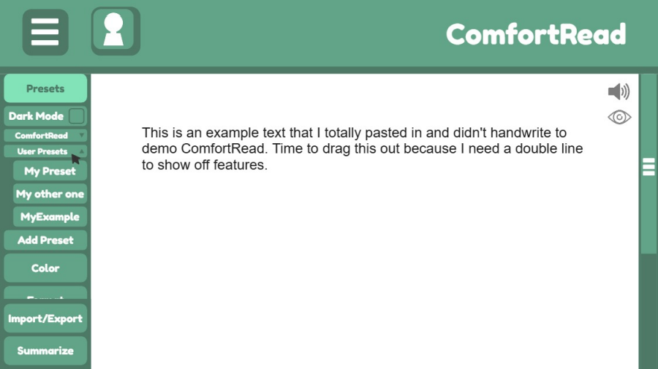

**Create new preset with name**

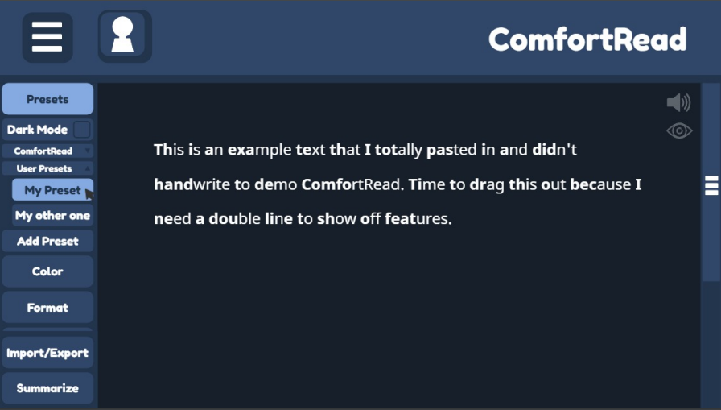

**This is an example of what a user would see after enabling preset; a preview of what ComfortRead can do**

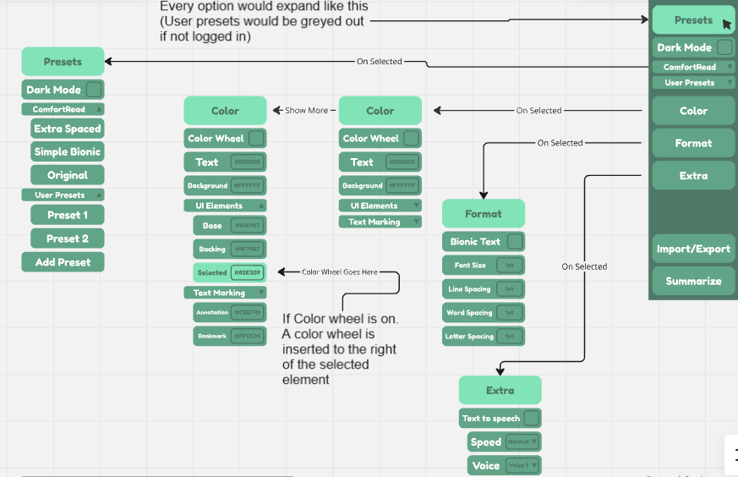

**An in depth view of each option and what they are when clicked**

*<Describe the logical characteristics of each interface between the software product and the users. This may include sample screen images, any GUI standards or product family style guides that are to be followed, screen layout constraints, standard buttons and functions (e.g., help) that will appear on every screen, keyboard shortcuts, error message display standards, and so on. Define the software components for which a user interface is needed. Details of the user interface design should be documented in a separate user interface specification.>*

## **Hardware Interfaces**

*<Describe the logical and physical characteristics of each interface between the software product and the hardware components of the system. This may include the supported device types, the nature of the data and control interactions between the software and the hardware, and communication protocols to be used.>*

## **Software Interfaces**

*<Describe the connections between this product and other specific software components (name and version), including databases, operating systems, tools, libraries, and integrated commercial components. Identify the data items or messages coming into the system and going out and describe the purpose of each. Describe the services needed and the nature of communications. Refer to documents that describe detailed application programming interface protocols. Identify data that will be shared across software components. If the data sharing mechanism must be implemented in a specific way (for example, use of a global data area in a multitasking operating system), specify this as an implementation constraint.>*

## **Communications Interfaces**

*<Describe the requirements associated with any communications functions required by this product, including e-mail, web browser, network server communications protocols, electronic forms, and so on. Define any pertinent message formatting. Identify any communication standards that will be used, such as FTP or HTTP. Specify any communication security or encryption issues, data transfer rates, and synchronization mechanisms.>*

# **System Features**

*<This template illustrates organizing the functional requirements for the product by system features, the major services provided by the product. You may prefer to organize this section by use case, mode of operation, user class, object class, functional hierarchy, or combinations of these, whatever makes the most logical sense for your product.>*

## **System Feature 1**

*<Don’t really say “System Feature 1.” State the feature name in just a few words.>*

4.1.1 Description and Priority

*<Provide a short description of the feature and indicate whether it is of High, Medium, or Low priority. You could also include specific priority component ratings, such as benefit, penalty, cost, and risk (each rated on a relative scale from a low of 1 to a high of 9).>*

4.1.2 Stimulus/Response Sequences

*<List the sequences of user actions and system responses that stimulate the behavior defined for this feature. These will correspond to the dialog elements associated with use cases.>*

4.1.3 Functional Requirements

*<Itemize the detailed functional requirements associated with this feature. These are the software capabilities that must be present in order for the user to carry out the services provided by the feature, or to execute the use case. Include how the product should respond to anticipated error conditions or invalid inputs. Requirements should be concise, complete, unambiguous, verifiable, and necessary. Use “TBD” as a placeholder to indicate when necessary information is not yet available.>*

*<Each requirement should be uniquely identified with a sequence number or a meaningful tag of some kind.>*

REQ-1: ComfortRead shall have an option to let the user reformat the text for **bio**nic **rea**ding.

REQ-2: ComfortRead shall have an experiment option that cycles preset formats for users unsure of what reading style is most comfortable for them.

REQ-3: ComfortRead shall have an option for text to speech that can be set to different reading speeds.

REQ-4: ComfortRead shall let the user choose custom text and background color options.

REQ-5: ComfortRead shall have an option to let users save their formatting preferences.

REQ-6: ComfortRead shall have an option for users to paste text into the document.

REQ-7: ComfortRead shall have an option to enable a Dark Mode that changes the page to a darker preset color scheme.

REQ-8: ComfortRead shall have a feature that allows users to export formatted text as an HTML file.

REQ-9: ComfortRead shall allow the user to adjust the interletter spacing of the input text.

REQ-10: ComfortRead shall allow the user to adjust the interword spacing of the input text.

REQ-11: ComfortRead shall allow the user to request a generative AI summary of the input text.

REQ-12: ComfortRead shall display the generative AI summary with the same reformatting options the user applied to the input text

REQ-13: ComfortRead shall have a feature that allows users to adjust the font size of the input text.

REQ-14: ComfortRead shall have a feature that allows users to adjust the font style of the input text.

REQ-15: ComfortRead shall have a feature that allows users to adjust the line spacing of the input text.

REQ-16: ComfortRead shall have an option for text to speech that can be set to different reading voices.

REQ-17: ComfortRead shall have the option to go distraction-free by hiding all controls and formatting options.

REQ-18: ComfortRead shall have a preset that allows for the user to reset their changes.

REQ-19: ComfortRead shall have a feature that allows users to lookup word definitions.

REQ-20: ComfortRead shall allow users to highlight and annotate text for future reference.

REQ-21: ComfortRead shall have an option for users to import text from a plain text file .

## **System Feature 2 (and so on)**

# **Other Nonfunctional Requirements**

## **Performance Requirements**

*<If there are performance requirements for the product under various circumstances, state them here and explain their rationale, to help the developers understand the intent and make suitable design choices. Specify the timing relationships for real time systems. Make such requirements as specific as possible. You may need to state performance requirements for individual functional requirements or features.>*

NF-REC 1.1: ComfortRead shall authenticate users and provide account access within two seconds of submitting valid login details to ensure a responsive system.

NF-REC 1.2 ComfortRead shall update formatting changes within three seconds per 1000 characters of text.

## **Safety Requirements**

*<Specify those requirements that are concerned with possible loss, damage, or harm that could result from the use of the product. Define any safeguards or actions that must be taken, as well as actions that must be prevented. Refer to any external policies or regulations that state safety issues that affect the product’s design or use. Define any safety certifications that must be satisfied.>*

NF-REC 2.1: ComfortRead shall warn users with a popup when they click on “summarize” that, “Generative AI summaries should not be used as a substitute for reading and understanding the input text, only as an unreliable aid.”

## **Security Requirements**

*<Specify any requirements regarding security or privacy issues surrounding use of the product or protection of the data used or created by the product. Define any user identity authentication requirements. Refer to any external policies or regulations containing security issues that affect the product. Define any security or privacy certifications that must be satisfied.>*

NF-REC 3.1: ComfortRead shall encrypt all sensitive data such as user credentials, uploaded text, and saved data to ensure data remains secure.

NF-REC 3.2: ComfortRead shall automatically log users out after thirty minutes of inactivity to prevent unauthorized access.

## **Software Quality Attributes**

*<Specify any additional quality characteristics for the product that will be important to either the customers or the developers. Some to consider are: adaptability, availability, correctness, flexibility, interoperability, maintainability, portability, reliability, reusability, robustness, testability, and usability. Write these to be specific, quantitative, and verifiable when possible. At the least, clarify the relative preferences for various attributes, such as ease of use over ease of learning.>*

NF-REC 4.1: ComfortRead shall be able to hide 90% of the user interface.

NF-REC 4.2: ComfortRead shall be fully functional and responsive on both desktop and mobile devices

NF-REC 4.3: ComfortRead shall never exceed an error rate of 10% when summarizing text under 1000 characters.

NF-REC 4.4: ComfortRead shall handle unexpected user input (unsupported file types or irregular text files) gracefully by providing meaningful error messages.

## **Business Rules**

*<List any operating principles about the product, such as which individuals or roles can perform which functions under specific circumstances. These are not functional requirements in themselves, but they may imply certain functional requirements to enforce the rules.>*

NF-REC 5.1: ComfortRead shall only limit non logged in users from saving reformatting options  
NF-REC 5.1: ComfortRead shall allow non-logged-in users to access all features, except for import/export options.

# **Other Requirements**

*<Define any other requirements not covered elsewhere in the SRS. This might include database requirements, internationalization requirements, legal requirements, reuse objectives for the project, and so on. Add any new sections that are pertinent to the project.>*

**Appendix A: Glossary**

*<Define all the terms necessary to properly interpret the SRS, including acronyms and abbreviations. You may wish to build a separate glossary that spans multiple projects or the entire organization, and just include terms specific to a single project in each SRS.>*

**Appendix B: Analysis Models**

*<Optionally, include any pertinent analysis models, such as data flow diagrams, class diagrams, state-transition diagrams, or entity-relationship diagrams*.>

**Appendix C: To Be Determined List**

*<Collect a numbered list of the TBD (to be determined) references that remain in the SRS so they can be tracked to closure.>*